Assessment is the process of collecting information with regard to abilities, Interest, aptitude, personality, attitude and beliefs in order to measure the ability. Psychological assessment is a process that involves the integration of information From multiple sources, such as tests related to ability, intelligence, interests or Attitudes, as well as information from personal interviews. Collateral information Is also collected about personal, occupational, or medical history, such as from Records or from interviews with parents, spouses, teachers, or previous therapists Or physicians. Moreover the psychological assessment is a structured interview That gathers information from and/or tests a person to evaluate his or her mental Health.

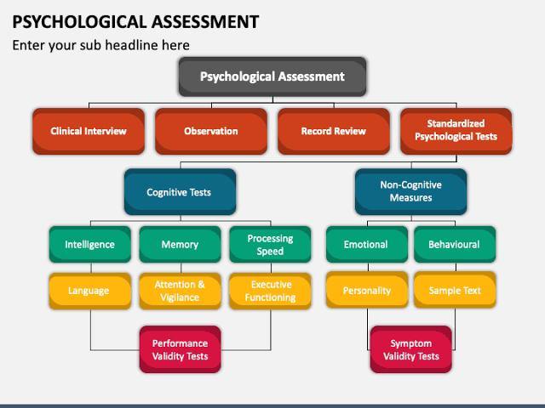

**Classification**

**Clinical Interview**

The clinical interview has been a critical and often primary assessment Component of mental health practice in psychology and psychiatry. As one of the Most commonly used assessments, it allows for efficient and relevant information Gathering for diagnostic and treatment considerations. Clinical interviews are also Cost effective and efficient in comparison to other assessment methods that require Specialized equipment (e.g., psychological and neuropsychological testing) and can Be used across many settings and with a wide variety of patients with diverse presenting concerns. First, the interview is a professional endeavour, often conducted by A mental or medical health professional who has been trained in the interview process and for a specific purpose related to the client’s psychological or physical Well-being. To the extent that the interview requires complex or sensitive data, the Training may be extensive and require refined clinical skill to complete well. Second, the type of information exchanged in the interview may differ substantially From the exchange that occurs in conversations. Both exchanges involve the verbal And nonverbal communication of objective and subjective information, and this Information may vary widely from one interview to the next. However, unlike a Conversation, the interview almost always involves topics that are considered sensitive or private in nature, such as trauma history, feelings of guilt, depression And suicidality, criminal behavior, sexual inadequacies and infidelities, medical Information, etc.

**Observation**

Observational assessments involve obtaining Evaluative information through direct observation. Although observational assessments could Potentially be used in any domain, they most Often are used for behavior, social-emotional Functioning, and language. A record of the examiner’s observations is kept for later interpretation. Considerations in conducting observational Assessments include decisions about which specific behaviors to target for observation; when,Where, and for how long observations should be Conducted; and the validity and reliability of Observational data. If observational assessments Are reliable, then multiple examiners observing A student’s behavior at the same time should have A high degree of agreement in their records of Specific behaviors; if observations are valid, they Should target behaviors that are well defined And representative of concerns about a student’s Social-emotional, behavioral, or linguistic Functioning.

**Record Review**

It entails studying data that has already been recorded and involves summarizing the data, subjecting it to appropriate statistical analysis and drawing inferences. It has been widely used in various clinical disciplines like medicine , pediatrics , psychiatry. Record reviews can provide important information about a people medical background, past experiences, and behavioral and academic history. Old behavioral support plans may show the progression of a people's problem behavior and point to intervention strategies that were successful in the past. Behavior support plans that have been abandoned often provide information about the types of interventions that, although technically accurate, may not be a good fit for the people implementing the plan.

**Psychology tests**

1. **Cognitive tests**

* Intelligence test: IQ tests purport to be measures of intelligence, IQ (or cognitive) Tests and achievement test are common norm-referenced tests. In these types of Tests, a series of tasks is presented to the person being evaluated, and the person’s Responses are graded according to carefully prescribed guidelines. After the test Is completed, the results can be compiled and compared to the responses of a Norm group, usually composed of people of the same age or grade level as the Person being evaluated.
* Tests of Interest and Aptitude: Tests of Interest assesses the likes and dislikes Of the client whereas aptitude tests aim at measuring the potential of the client in A particular field. These are mainly used for the educational and vocational Counselling
* Attitude tests: Attitude test assess an individual’s feelings about an event, person,Or object. Attitude scales are used in marketing to determine individual (and Group) preferences for brands, or items.
* Neuro-psychological tests: These tests consist of specifically designed tasks Used to measure a psychological function known to be linked to a particular Brain structure or pathway. They are typically used to assess impairment after an Injury or illness known to affect neuro-cognitive functioning, or when used in Research, to contrast neuropsychological abilities across experimental groups.

1. **Non cognitive tests**

* Personality tests: Personality tests and inventories evaluate the thoughts, Emotions, attitudes, and behavioural traits that comprise personality. The results Of these tests can help determine a child’s personality strengths and weaknesses, And may identify certain disturbances in personality. Psychological measures of Personality consist of rating scale or self-report measures and free response Measures or projective tests.
* Behavioral assessment: It is a systematic process of evaluating and measuring an individual’s behaviors, competencies, and traits to assess their suitability. It involves observing and analyzing how candidates respond to various situational scenarios to predict their actions.